Health Insurance Portability and Accountability Act

(Style Guidelines for Final Year Project ReportsHIPAA)
Final Year Project Proposal
Session 2023-2027
A 4th Year Student

A project submitted in partial fulfillment of the
COMSATS University Degree
of
BSc. (Hons.)BS in Computer Science / Software Engineering (CUI)


Department of Computer Science
COMSATS University Islamabad, Lahore Campus

Project Registration
Project ID (for office use)
Type of project |  |  | [ ] Traditional [] Industrial [ ] Continuing
Nature of project |  |  | [ ] Development [] Research & Development
Sustainable Development Goals(SDGs) |  |  | [] Good Health and Well-Being [ ] Quality Education  [] Industry, Innovation, and Infrastructure [ ] Gender Equality  [] Decent Work and Economic Growth [ ] Climate Action
Area of specialization |  |  | [] Artificial Intelligence (AI) [ ] Blockchain [ ] Cybersecurity  [] Data Science and Analytics [ ] Game Development  [ ] Internet of Things (IoT) [] Natural Language Processing (NLP)  [ ] Mobile App Development [] Web Development
Project Group Members
Sr.# | Reg. # | Student Name |  | Email ID | Phone # | Signature
(i) | SP23-BCS-001 | Abdul Rehman |  | Sp23-bcs-001@cuilahore.edu.up | 0324-4806989
(ii) | SP23-BCS-032 | Ayesh Ahmad |  | Sp23-bcs-032@cuilahore.edu.pk | 0316-4506074
(iii) | SP23-BCS-029 | Asad Rasheed |  | Sp23-bcs-029@cuilahore.edu.pk | 03029700678
Declaration: FYP group members have cleared all prerequisite courses For FYP-I as per their degree requirements.
For BS (Computer Science), BS (Software Engineering), and BS (Artificial Intelligence)
(CSC241 Object Oriented Programming, CSC291 Software Engineering Concepts, CSC270 Database Systems, HUM102 Report Writing Skills)
Plagiarism Free Certificate
This is to certify that, I am Abdul Rehman S/D/o Muhammad Ashfaq, group leader of FYP under registration no CUI /SP23-BCS-001/LHR at the Computer Science Department, COMSATS Institute of Information Technology, Lahore. I declare that my FYP proposal is checked by my supervisor and the similarity index is ________% that is less than 20%, an acceptable limit by HEC. The report is attached herewith as Appendix A.
Date: 8 October 2025 Name of Group Leader: AbdulRehman Signature: __________
Name of Supervisor: Zeenat Afzal Co-Supervisor (if any):_________________
Designation: _____________________ Designation: _____________________
Signature: _____________________ Signature: _____________________
Contents
Health Insurance Portability and Accountability Act 1
(HIPAA) 1
Project Registration 2
ABSTRACT 4
1. Introduction 5
2. Problem Statement 6
3. Project Objective 6
4. Related Work 7
5. Proposed Methodology & Architecture 8
6. Success Criterion 12
7. Team Roles And Responsibilities 14
8. Tools and Technologies 16
9. References 17

ABSTRACT
Home health and hospice agencies handle many important documents of patients to report the to hospitals and doctors for better treatment of the patient like OASIS and plan of Care forms. These documents are long, detailed, and often filled out manually, which makes the process slow and increases the chances of mistakes, which causes the compliance issues, delayed claims and more work for the healthcare staff.
Our project aims to solve this problem by building an AI-powered document automation system.
The system allows healthcare workers to upload documents securely. The AI then reads and extracts the required data, fills in missing details, and organizes everything automatically while keeping patient information private and secure. This system allows healthcare professionals to access the documents of the patients more easily and rapidly than conventional documents.
In addition, it also changes the homecare system for patients to another level. There will be a patients interface which will help the homecare staff or family member to keep track of patients medication, directly ask questions and the Ai will answer questions according to the previous records of the patients and it will also provide the real time info of patients homecare to the doctors, which in-future can also become useful to predict risk of emergency for the patent according to his history and condition.
Overall, this system aims to make clinical documentation faster, more accurate, and more connected, improving both healthcare operations and patient outcomes.

Introduction

1.1. Domain Background
Home health and hospice care are the two fastest growing segments in healthcare that provide medical support and comfort to the patients at home. The patients with chronic diseases who need continuous care and monitoring are the major consumers of these services. In this scenario, documentation is the most important thing that should be taken care of as it is communication among the nursing, medical, and administrative personnel because whenever that patient will go under treatment decisions are done considering these documents. The OASIS and POC forms are the foundation on which the documentation of patient information, treatment plans, and progress reporting rests.
However, most of the documentation is still performed in a manual way using paper methods and digital tools that have become outdated, the employees often spend a lot of time performing the same task of data entry instead of taking care of the patients. Manually recording everything leads to more chances of making mistakes, losing information, and delay in communication among the medical teams. These problems are very much linked with patient safety, care quality, and following the laws. The increasing need for home healthcare services is putting more pressure on medical institutions to have digital systems that are faster and more reliable.

1.2. Motivation and Significance of the Project
The motivation for this project comes from the growing burden on home health agencies to handle complex documentation accurately and quickly. According to healthcare studies, documentation errors and incomplete records are the top issues that the a agencies are facing which causes claim rejections and compliance violations in the homecare sector (HealthIT.gov, 2023). Automating this process using artificial intelligence can greatly reduce these issues by improving accuracy and speed. The project is important because it not only reduces the workload on healthcare workers but also ensures that patients receive timely and error-free care. By integrating AI into healthcare documentation, agencies can maintain compliance with HIPAA regulations while improving efficiency and data quality.

1.3. Objectives and Scope of the Project
The primary scope of the project will be to get an intelligent document system for health care workers in Home care. To achieve this system will get a combination of OCR and Machine learning to get and validate patient information from various form and other types of documents moreover the project will create an app for patients to check their medications. It will also involve error detection and cloud storage.

1.4. Proposed Solution
The proposed solution is a cloud-based platform that employs AI and NLP for the automatic processing of healthcare documents. A secure interface allows users to add patient-related documents. The AI will scrutinize the text and extract necessary details, fill in the gaps, and output neat digital records. There will be a patient portal through which healthcare personnel and caregivers can monitor the patient's care actions and ask questions, while doctors will get real-time notifications. Patient confidentiality is guaranteed, and legal requirements are met through the use of encryption and role-based access control.

1.5. Results or Outcomes
The expected outcome of this project is a working prototype of an intelligent document automation system that reduces manual workload, minimizes errors, and accelerates patient’s data management. Home care workers can access patient information accuratly improving efficiency of service It will also enhance the communication between patients and doctors This system can also provide analytics for future health risks

Problem Statement
Home health and hospice (HHH) agencies rely heavily on manual documentation processes for completing OASIS and Plan of Care (POC) forms, which are critical for patient assessment, care planning, and regulatory compliance. The presence of document errors, absence of vital information, and differences in figures have become frequent disturbances in medical practices through the long and complicated documents; the issues then trickle down to the violation of compliance, denial of claims, and the increment of clinician's workload. The existing digital solutions merely implement partial automation, do not grasp the situation of the clinical notes at all, and do not have the potential to provide foresight about the patients' health in terms of the outcome. Moreover, compliance with HIPAA regulations for data handling and model deployment is still a huge barrier for AI in the healthcare sector, hence the pressing need for a smart, safe, and compliant AI assistant that can perform document QA, generate clinician-editable care plans, and predict 30-day return-to-hospital (RTH) risk thus reducing administrative work while ensuring both regulatory and clinical accuracy.

Project Objective
- Create a secure web platform that accepts scanned PDFs/images as input, produces structured JSON outputs, and generates a draft Plan of Care (POC) containing source citations for each extracted field.
- Develop document OCR/KIE pipelines that achieve a macro-F1 score of at least 0.92 for key fields (patient ID, DOB, SOC date, ICD-10 primary, ADL/mobility), ensuring each field individually scores ≥ 0.90.
- Build a POC creation module using RAG + templates that achieves ≥ 70% section-level approval without modification during the pilot evaluation.
- Develop a baseline RTH risk model with 10–20 engineered features, achieving a Brier score ≤ 0.15 and an AUROC ≥ 0.78 on held-out data.
- Decrease reviewer time per form by at least 40% compared to the baseline, measuring active duration from “open” to “approve/submit,” excluding idle times over 5 minutes.
- Implement a human-in-the-loop review interface with clear accept, edit, and reject options, and maintain comprehensive audit logs of all model outputs and user interactions.
- Assess performance using established KPIs and document mean, median, 95% confidence intervals, and error distributions across template and scan quality in the golden set.
- Ensure privacy and security through role-based access control, encryption of data at rest and in transit, and strict prohibition of PHI sharing with external services, completing a checklist of at least 12 security measures.
- Deliver a reproducible, end-to-end Dockerized system that can be initialized from scratch within ≤ 2 hours using one setup script and documented configurations.
- Limit operational expenses to ≤ PKR X per form (to be finalized with stakeholders) while maintaining target accuracy and latency ≤ 30 seconds per page on average.
- Generate a one-page pilot report featuring three KPIs (time per form, extraction F1, POC acceptance), two graphs, and two to three anonymized reviewer statements.

Related Work

4.1. OCR and Key Information Extraction (KIE)
Traditional Optical Character Recognition (OCR) systems such as Tesseract continue to serve as robust benchmarks for printed text and can be integrated with rule-based post-processing for structured forms. However, layout-aware models surpass simple OCR + NLP methods for structured documents and invoices by simultaneously modeling text and 2D layout.
Key works:
Smith (Tesseract OCR), 2007; Chargrid (2018)

4.2. Layout-Aware Document AI
Pre-trained transformer models that process both text and layout lead KIE benchmarks for forms and receipts. LayoutLM (and its v2/v3 versions), DocFormer, and Donut (OCR-free) are among the most widely adopted frameworks depending on whether external OCR is preferred or integrated modeling is required.
Key works:
LayoutLM (2020), LayoutLMv2 (2020), LayoutLMv3 (2022), DocFormer (2021), Donut (2021/2022).

4.3. Clinical NLP, Datasets, and Risk-Prediction Context
MIMIC III is a standardized, de-identified electronic health record (EHR) dataset extensively used for clinical NLP and risk modeling research. The prediction of hospital readmission risk has a long history; systematic reviews show steady but moderate gains when applying machine-learning techniques to structured EH4.R data.
Key works:
MIMIC III (2016); Kansagara et al.

4.4. Grounded Generation (RAG) for Plan-of-Care Drafts
Retrieval-Augmented Generation (RAG) frameworks retrieve relevant source passages and guide text generation, improving accuracy and traceability features especially beneficial for clinical writing with references.
Key work:
Lewis et al., “Retrieval Augmented Generation,” 2020.

4.5. Predictive Modeling, Calibration, and Evaluation
Gradient-boosted tree algorithms such as XGBoost and LightGBM are strong baselines for clinical risk assessment. Probability calibration techniques like Platt scaling and Isotonic regression are essential for generating reliable risk scores. Evaluation includes discrimination metrics (AUROC, AUPRC) and calibration metrics (ECE).
Key works:
XGBoost (2016); Platt (1999); Zadrozny & Elkan (2002).

4.6. Explainability
The SHAP framework provides localized, interpretable feature attributions, enabling clinicians to understand why a particular prediction was made and supporting transparent, trustworthy AI.
Key work:
Lundberg & Lee (2017).

Proposed Methodology & Architecture
The proposed system aims to design and implement a HIPAA-Compliant AI Platform tailored for the Home Health and Hospice (HHH) sector. The system will combine artificial intelligence, secure cloud architecture, and healthcare domain knowledge to automate routine clinical documentation, ensure data integrity, and help clinicians make more informed care decisions. The ultimate purpose is to support home health agencies and hospice providers by reducing manual errors, accelerating care plan generation, and improving the prediction of hospital readmission risks.
The platform’s foundation lies in strict adherence to the Health Insurance Portability and Accountability Act (HIPAA) regulations, which govern the handling of Protected Health Information (PHI). Every system component from storage and model training to user access will be developed to comply with HIPAA’s privacy and security rules. The project will use Microsoft Azure as the underlying infrastructure due to its healthcare-ready compliance certifications, integrated identity management, and AI ecosystem.

5.1. System Architecture Overview
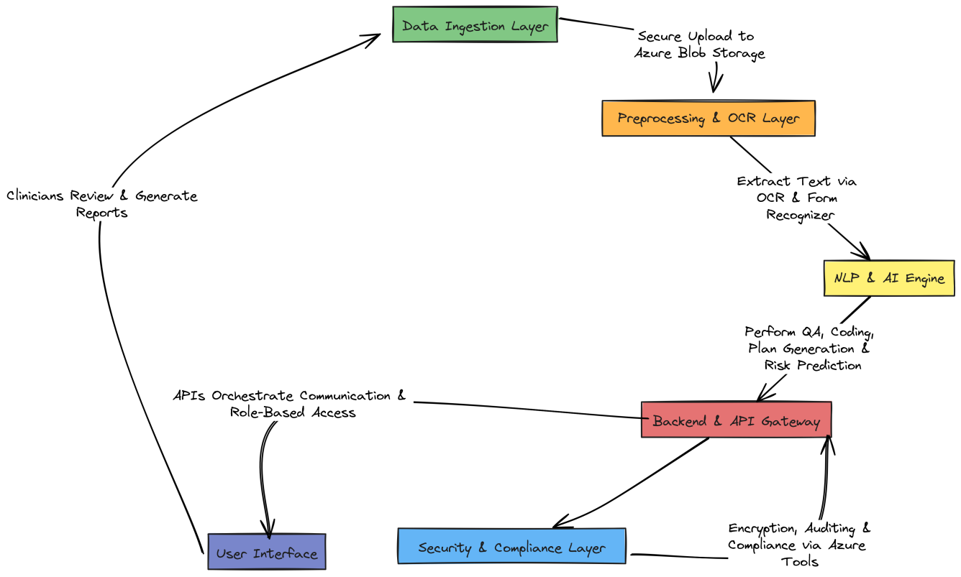
The proposed system architecture adopts a modular, microservice-based approach. It divides the complete workflow into independent services that can scale and operate securely without exposing patient data. Each module has a well-defined purpose that contributes to either document automation, AI inference, or compliance monitoring. They are as follows:
- Data Ingestion Layer: The process begins with the secure upload of patient documents such as OASIS E1 forms, Home Health Plans of Care (HPOC1), and Hospice Plans of Care (HPOC2). These files will be uploaded through a web interface into Azure Blob Storage. All transfers will be encrypted using HTTPS and stored within private containers accessible only via authenticated roles.
- Preprocessing and OCR Layer: Since many healthcare forms are handwritten or scanned, Azure Form Recognizer and Document Intelligence APIs will be used to perform Optical Character Recognition (OCR) and structured data extraction. These services automatically identify key-value pairs, tables, and checkbox responses from OASIS and POC templates. This step ensures that both printed and scanned inputs can be machine-readable and ready for further analysis.
- NLP and AI Engine: Once the text is extracted, the AI module will apply Natural Language processing techniques to validate data. This will perform 4 functions:

Quality Assurance: This will identify incomplete data
Plan of Care generation: It will automatically generate forms ensuring that treatment and medication is on schedule
OASIS: It will translate history and prescriptions into OASIS codes
Readmission Risk Prediction: Use structured patient data to identify high-risk individuals likely to be readmitted to the hospital within 30 days.
These capabilities will rely on pre-trained OpenAI models fine-tuned with anonymized medical text and supported by Azure Cognitive Services to ensure both accuracy and interpretability.
- Backend and API Gateway: The backend logic will be implemented using Azure Functions and Node.js REST APIs. These functions orchestrate communication between storage, AI models, and frontend modules. Each API endpoint will be protected by Azure Active Directory authentication and role-based access controls (RBAC), ensuring that clinicians, administrators, and AI trainers have access only to the information they are authorized to view.
- Security and Compliance Layer: Compliance is the backbone of this system. Azure Key Vault will handle encryption keys and secrets, ensuring that no credentials or sensitive data are hardcoded. Azure Monitor and Log Analytics will continuously record activity logs, which will later be reviewed for security audits. All components will operate within an Azure Virtual Network (VNet) with Private Endpoints, ensuring that no PHI ever traverses the public internet.
- User Interface: The user interface will be built as a responsive web portal using React.js hosted on Azure App Service. It will allow clinicians to upload forms, review AI-suggested corrections, generate care plans, and view risk scores. The interface will be simple, intuitive, and designed in consultation with healthcare professionals to ensure usability.

5.2. Methodological Steps
- Requirement Analysis: Conduct meetings with healthcare professionals to understand OASIS workflows, POC standards, and compliance constraints.
- Data Collection and Understanding: Gather publicly available OASIS and CMS plan templates, alongside synthetic patient data, ensuring all training datasets are de-identified and HIPAA-compliant.
- Preprocessing: Use OCR and text normalization techniques to clean and structure input data for AI processing.
- Model Development: Build and fine-tune NLP models for automatic document filling and QA verification. Develop machine learning algorithms (e.g., logistic regression, decision trees) for risk prediction.
- System Integration: Combine the NLP engine, AI models, and backend through Azure Functions, ensuring seamless communication via REST APIs.
- Security Enforcement: Configure private networking, encryption-at-rest, and access controls to ensure full compliance with HIPAA and Azure Security Center guidelines.
- Testing and Validation: Conduct performance testing, accuracy evaluation, and end-user validation to confirm that the system meets both technical and healthcare standards.
- Deployment and Monitoring: Deploy the application in a secure Azure environment using DevOps pipelines, followed by continuous monitoring for anomalies or breaches.

5.3. Architecture Diagram
The overall system workflow is visually represented below, illustrating how patient data flows.
securely from ingestion to final insights

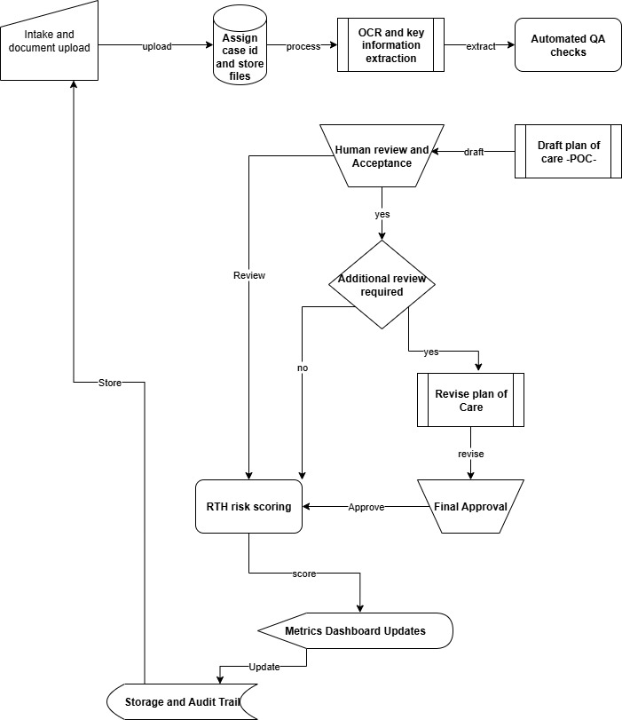

Figure 1. HIPAA-Compliant AI System Architecture Diagram.

Success Criterion
The success of this project will be measured against clearly defined, quantifiable objectives that align with both technical excellence and clinical relevance. The criteria below will determine whether the system has achieved its intended outcomes

6.1. Criteria
- Document Processing Accuracy: The AI model should correctly extract, interpret, and validate data fields in OASIS and Plan of Care documents with at least 90% precision.
- Plan of Care Generation Quality: This will generate care plans that will be acceptable up-to 95%.
- Readmission Risk Prediction Reliability: This model will achieve a score of at least 85% for high risk patient
- Data Security and HIPAA Compliance: All data must be encrypted, It must ensure that no unauthorized access occurs.
- System Responsiveness: It should process documents to generate results with low outcome time.
- Clinical Usability and Feedback: After the deployment surveys should be done and it should maintain high satisfaction rate.
- Scalability and Integration: The architecture should successfully integrate with Azure’s private endpoints, APIs, and databases without any breach or performance bottleneck.
- Audit and Monitoring: All system logs should demonstrate traceability and full compliance during simulated HIPAA audit testing.
Overall, the project will be deemed successful if it demonstrates that AI can be effectively and securely used to assist healthcare professionals in automating documentation, improving data quality, and predicting patient outcomes—all while maintaining full HIPAA compliance. The successful completion of this project will not only highlight the integration of artificial intelligence and cloud technologies in healthcare but also set a precedent for developing ethically sound, regulation-compliant AI solutions in sensitive domains.

6.2. Upsides (Why This Project Is Worth Doing)
- Time Saved Where It Actually Hurts
Nurses and admins spend hours re-typing data from scanned forms into EMR systems. The OCR → KIE → validation pipeline automates this process.
Example: A 6-page intake + POC form that usually takes 18–25 minutes can drop to 5–7 minutes when most fields are pre-filled.
Metric: ≥ 60 % reduction in average completion time.
- Fewer Costly Mistakes
Typos in ICD codes, missing dates, or mismatched patient IDs lead to denials. Built-in validation rules (e.g., SOC date < discharge date) and medical dictionaries flag errors instantly.
Metric: 30–40 % reduction in denial/rework rate.
- Clinicians Get a Better Starting Point, Not a Black Box
Each POC sentence links to its source snippet or policy reference, enabling traceable AI outputs that build clinician trust and speed up review.
- Early Risk Signals You Can Act On
A calibrated risk score (e.g., ≥ 0.35) with a short explanation—“recent ER visit, polypharmacy, low mobility”—helps prioritize follow-ups.
Metric: Precision/recall on pilot data + % of alerts acted on within 72 hours.
- Built to Iterate, Not a One-Off System
The design is modular: OCR/KIE, RAG drafting, and risk modeling are separate services. Improvements in one do not require retraining the others.
- Realistic for Deployment in Pakistan
Local clinics with limited bandwidth can run Tesseract + lightweight layout models offline, while larger LLM/RAG modules can operate in batch or cloud-optional mode.
Cost control: Cache OCR results and trigger LLM calls only when drafts are opened.
- High Learning and Career Value
The project spans Document AI, RAG, tabular ML, model calibration, security, and MLOps, giving students full-stack AI engineering exposure.

6.3. Downsides (Risks) and Mitigation Strategies
- Handwriting and Low-Quality Scans
OCR struggles with faint or skewed pages.
Mitigation: Enforce ≥ 300 DPI scans; add a “rescan needed” prompt; enable spot-fix UI; apply ICR only for high-impact fields.
- Hallucinations in POC Drafts
LLMs may generate unsupported statements.
Guardrails: Retrieval-first design, source citation enforcement, amber highlights for uncertain data, and mandatory human sign-off.
- Uncalibrated Risk Model
AUC alone can mislead.
Mitigation: Always calibrate on a site-specific hold-out set, show reliability diagrams, and recalibrate quarterly.
- Data Privacy and Approvals
Mitigation: Use synthetic/redacted data during development; enforce role-based access, encryption at rest/in transit, and 12-month audit logs.
- Cloud Cost and Latency
Mitigation: Use local OCR by default, cache results, batch heavy LLM tasks, and display cost metrics per document on the dashboard.

Team Roles And Responsibilities

7.1. Roles:
Team Member | Technical Responsibilities | Specific Components / Tasks
Abdul  Rehman | AI Model Training, and Cloud Infrastructure  Documentation, Compliance Validation | Develop and train ML models (XGBoost / LightGBM) for 30-day Readmission Risk Prediction.  Integrate SHAP Explainable AI for model transparency.  Configure and manage Azure Cloud Infrastructure including Blob Storage, AI Search, and Key Vault.  Set up secure networking (Private Endpoints, VNet, RBAC).  Implement CI/CD pipelines and monitor model deployments using Azure DevOps.  Ensure HIPAA compliance encryption, audit logs, and access control  Create system architecture diagrams and technical documentation.
Asad Rasheed | Backend Development, Research, System Coordination, | Develop backend system using FastAPI and design all REST APIs for data and model interaction.  Integrate OCR and AI pipelines using Azure Form Recognizer and Document Intelligence.  Conduct requirement analysis and collect healthcare compliance (HIPAA, CMS) specifications.  Lead research documentation, writing: Abstract, Introduction, Problem Statement, Related Work, Methodology, and Success Criteria.  Evaluate model accuracy metrics and compile backend + compliance documentation.  Implement data encryption, API authentication, and backend security validation.  Test system integration with Postman and manage research coordination.
Ayesh Ahmed | Frontend Development and Clinician Interface Design | Develop responsive web portal using Next.js (React + TypeScript).  Build clinician dashboard for document upload, QA review, Plan of Care editing, and risk visualization.  Implement semantic search and RAG-based chat interface for clinician interaction.  Design UI using TailwindCSS or MUI ensuring usability and accessibility.  Integrate frontend with backend APIs and authentication via Azure Active Directory.  Handle testing of UI workflows and clinician feedback integration.  Participate in final integration testing and performance optimization.
Table 1. Individual Tasks

7.2. Gantt Chart:

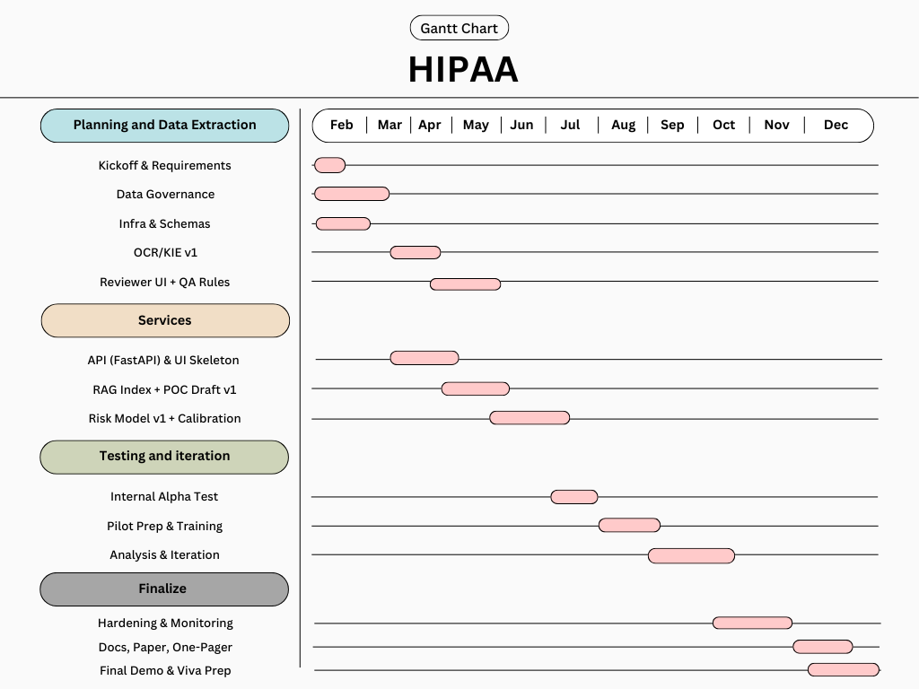
Figure 2. Gantt Chart

Tools and Technologies

8.1. Frontend
- Next.js (React + TypeScript), Tailwind or MUI for UI.
  - Why: Fast developer velocity, Server-Side Rendering (SSR) for secure pages, great ecosystem.

8.2. Backend/API
- Python + FastAPI
  - Why: Clean typing, easy async, first-class ML/LLM tooling.
  - Alt: Node.js + NestJS (if your team prefers TypeScript end-to-end).

8.3. Data + Storage (Azure-friendly)
- PostgreSQL for metadata + user/auth.
- Azure Blob Storage for documents.
- Azure AI Search for semantic + vector search.
- Azure Key Vault for secrets.

8.4. AI/ML Components
- OCR/KIE: Azure AI Document Intelligence (Form Recognizer) with a small custom model for your form layouts.
- LLM for drafting/QA: Azure, OpenAI GPT-4o or GPT-4o-mini (cost saver) behind Retrieval-Augmented Generation (RAG).
- Embeddings: Text-embedding model from Azure OpenAI (e.g., text-embedding-3-large or cost-efficient small).
- RTH model: scikit-learn + XGBoost/LightGBM; SHAP for explanations.
- Alternative LLM: Or, if Azure access is limited: open-source LLM (Llama 3.x Instruct) via an API or local inference for demos.

9. References
^{[1]} R. Smith, “An overview of the Tesseract OCR engine,” Proc. ICDAR, 2007, pp. 629–633, doi: 10.1109/ICDAR.2007.4376991.
^{[2]} Y. Huang, T. Lv, L. Cui, Y. Lu, and F. Wei, “LayoutLMv3: Pre-training for Document AI with unified text and image masking,” arXiv:2204.08387, 2022.
^{[3]} S. Appalaraju, B. Jasani, B. U. Kota, Y. Xie, and R. Manmatha, “DocFormer: End-to-end transformer for document understanding,” Proc. ICCV, 2021; arXiv:2106.11539.
^{[4]} G. Kim, T. Hong, M. Yim, et al., “OCR-free document understanding transformer (Donut),” Proc. ECCV, 2022.
^{[5]} A. E. W. Johnson, T. J. Pollard, L. Shen, et al., “MIMIC-III, a freely accessible critical care database,” Scientific Data, vol. 3, 160035, 2016, doi: 10.1038/sdata.2016.35.
^{[6]} D. Kansagara, H. Englander, A. Salanitro, et al., “Risk prediction models for hospital readmission: A systematic review,” JAMA, vol. 306, no. 15, pp. 1688–1698, 2011, doi: 10.1001/jama.2011.1515.
^{[7]} P. Lewis, E. Perez, A. Piktus, et al., “Retrieval-augmented generation for knowledge-intensive NLP tasks,” arXiv:2005.11401, 2020.
^{[8]} T. Chen and C. Guestrin, “XGBoost: A scalable tree boosting system,” Proc. KDD, 2016, pp. 785–794, doi: 10.1145/2939672.2939785.
^{[9]} C. Guo, G. Pleiss, Y. Sun, and K. Q. Weinberger, “On calibration of modern neural networks,” Proc. ICML, 2017, pp. 1321–1330.
^{[10]} S. M. Lundberg and S.-I. Lee, “A unified approach to interpreting model predictions,” Proc. NeurIPS, 2017, pp.
Appendix A

Appendix B
